ABOUT SUNSATIONTRAVEL, LLC

We specialize in small group tours and custom destination packages. With significant international experience, we are dedicated to providing exceptional quality travel experiences
tailored to suit your personal interests. SunsationTravel offers something for everyone.

MEET THE OWNER

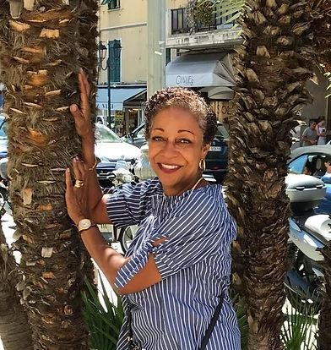
When I decided to retire after more than 30 years in private industry, I wanted to do something exciting, but not something that felt like a job.

It didn't take long to realize my passion for travel. So in 2017, I invested in an online course to become a certified travel agent. Best move ever...

In a short few years, I have traveled to destinations around the globe and have met some incredible people! I've learned that travel teaches you without a scorecard. There's just so much to embrace - meeting new people, getting acquainted with different cultures, and tasting new cuisines!

There's no doubt, I am living my best life and I invite you to join me to do the same...

Joyce A. Harris, Proprietor

